**Analytics For Hospitals' Health-Care Data**

Recent Covid-19 Pandemic has raised alarms over one of the most overlooked areas to focus: Healthcare

Management. While healthcare management has various use cases for using data science, patient length of stay is one critical parameter to observe and predict if one wants to improve the efficiency of the healthcare management in a hospital.

This parameter helps hospitals to identify patients of high LOS-risk (patients who will stay longer) at the time of admission. Once identified, patients with high LOS risk can have their treatment plan optimized to minimize LOS and lower the chance of staff/visitor infection. Also, prior knowledge of LOS can aid in logistics such as room and bed allocation planning.

Suppose you have been hired as Data Scientist of Health Man – a not for profit organization dedicated to manage the functioning of Hospitals in a professional and optimal manner.

**Goal:**

The goal is to accurately predict the Length of Stay for each patient on case by case basis so that the Hospitals can use this information for optimal resource allocation and better functioning. The length of stay is divided into 11 different classes ranging from 0-10 days to more than 100 days.

**Technical Architecture:**

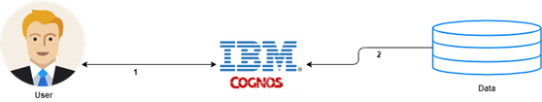

### Solution Requiremets

Services Used: IBM Cognos Analytics.

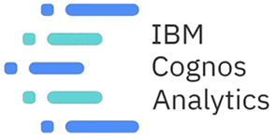

**Project Objectives**

By the end of this Project, you will:

* Know fundamental concepts and can work on IBM Cognos Analytics
* Gain a broad understanding of plotting different visualizations to provide the suitable solution.
* Able to create meaningful Visualizations and the Dashboard(s).

**Project Flow**

* Users create multiple analytical graphs/charts/Visualizations.
* Using the Analytical Visualizations, build the required Dashboard(s).
* Saving and visualizing the final dashboard in the IBM Cognos Analytics.

To accomplish this, we have to complete all the activities and tasks listed below:

* IBM Cloud Account
* Login to Cognos Analytics
* Working with the Dataset
  + Understanding the Dataset
  + Loading the Dataset
* Build the following visualizations
  + Length of Stay for each case of patients.
  + Stay by Patient ID using Column Chart
  + Severity of illness by Patient-Id using Tree Map
  + Age, Department Wise Patient using Table
  + Room Availability by Pie Chart
  + Dashboard Creation
  + Department wise no. of admissions by Waterfall Chart